**BUSINESS PROBLEM**

In recent years, city hotels and resort hotels have seen high cancellation rates. Each hotels now dealing with number of issues as a result, including fewer revenues and less than ideal hotel room use. Consequently, lowering cancellation rates in both hotels. Primary goal is to increase their efficiency in generating revenue, and for us to offer thorough business advice to address this problem.

The analysis of hotel booking cancellations as well as other factors that have no bearing on their business and yearly revenue generation are the main topics of this report.

**ASSUMPTIONS**

1. No unusual occurrences between 2015 and 2017 will have substantial impact on data used.
2. The information is still current and can be used to analyze a hotel’s possible plans in efficient manner.
3. There is no unanticipated negatives to the hotel employing and advised technique.
4. The hotels are not currently using any of the suggested solutions.
5. The biggest factor affecting the effectiveness of earning income is booking cancellation.
6. Cancellations result in vacant rooms for the booked length of time.
7. Clients make hotel reservations the same year they make cancellations.

**RESEARCH QUESTION**

1. What are the variable that effect hotel reservation cancellations?
2. How can we make hotel reservations cancellations better?
3. How hotels will be assisted in making pricing and promotional decisions?

**HYPOTHESIS**

1. More cancellations occur when prices are higher.
2. When there is longer waiting list, customers tend to cancel more frequently.
3. The majority of the clients are coming from offline travel agents to make their reservations.

**ANALYSIS AND FINDINGS**

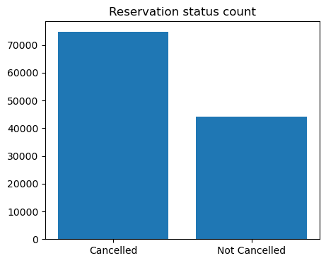

The accompanying bar graph show the percentage of reservations that are canceled and those are not. It is obvious that that there are still significant number of reservations that have not been canceled . There are still 37% of clients who canceled their reservation, which had significant impact on the hotel’s earning.

II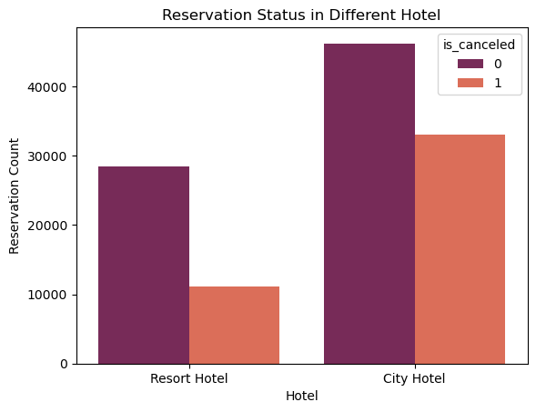

In comparison to the resort hotels, city hotels have more bookings. It is possible because of the prices of the resort hotels are higher than the city hotels.

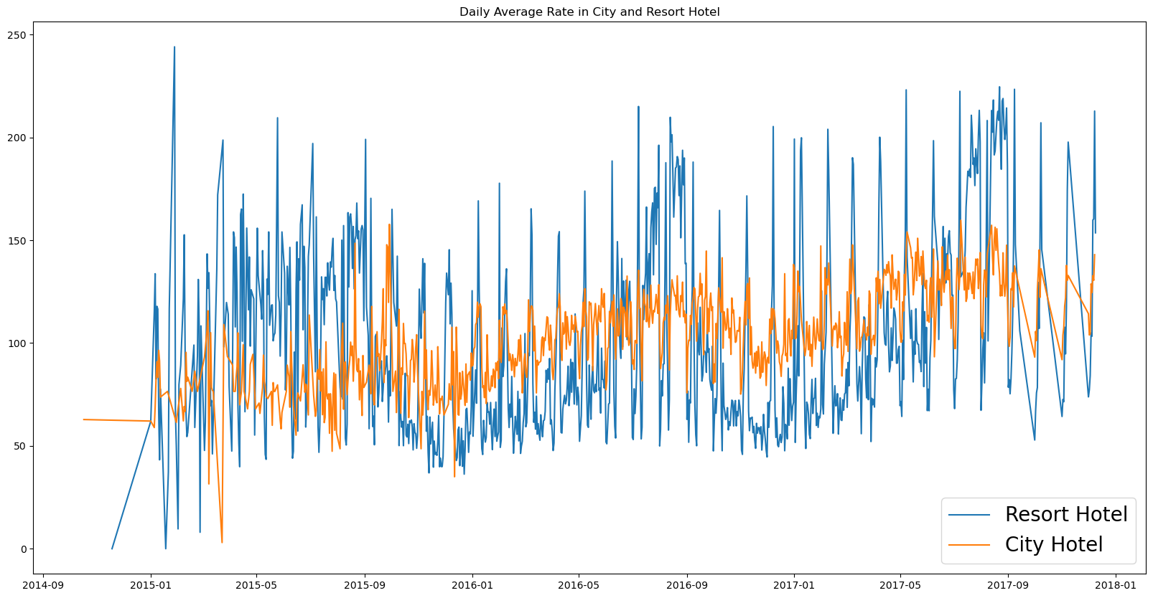

The line graph above shows that, on certain days, the daily average rate for a city hotel is less than that of a resort hotel, and on other days, it is even less . It goes without saying that weekends and holidays may see a rise in resort hotel rates.

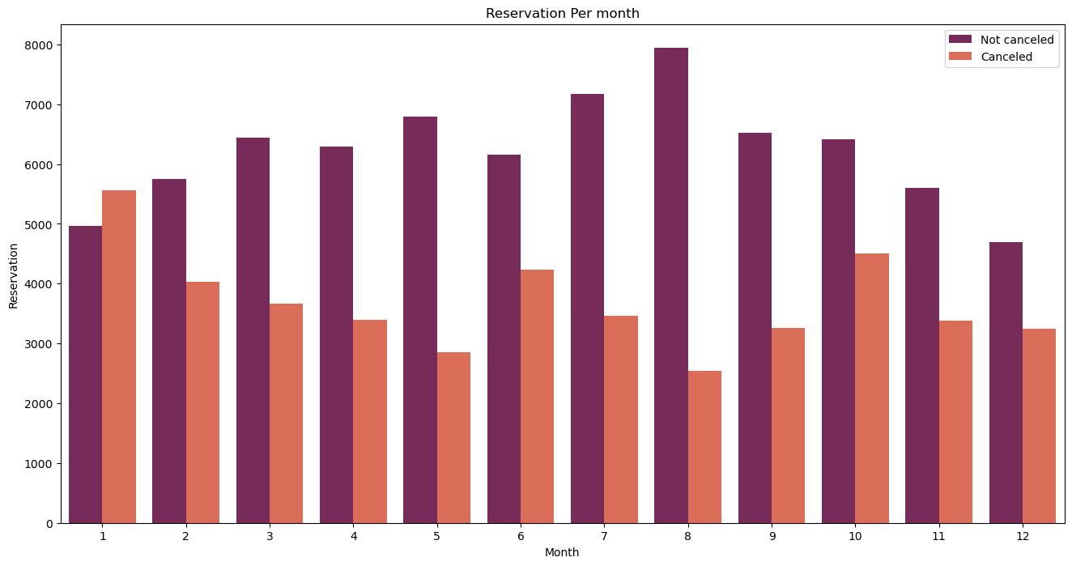

We have developed a group bar chart to analyze the months with highest and lowest reservation levels according to reservation status . As can seen, the number of confirmed reservation are higher in the month of August and canceled reservation are lowest in the month of August. January is the month with highest canceled reservations.

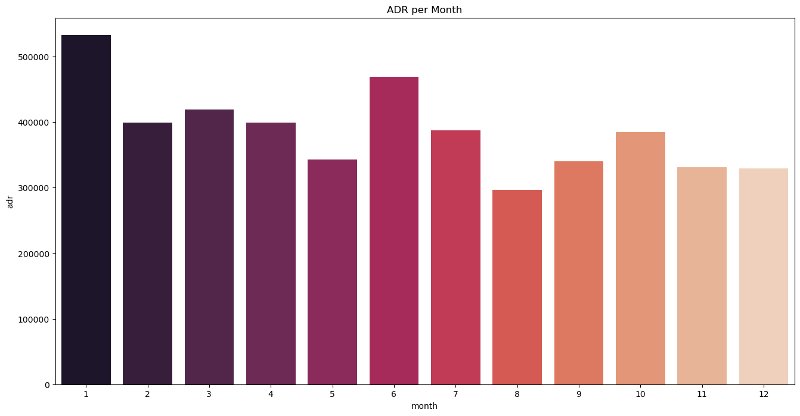

The above bar graph demonstrates that cancellations are most common when prices are greatest and least common when they are lowest. Therefore, cost of the accommodation is solely responsible for the cancellation .

Now, let’s see which country has the highest reservation canceled . The top country is Portugal with highest number of cancellations.

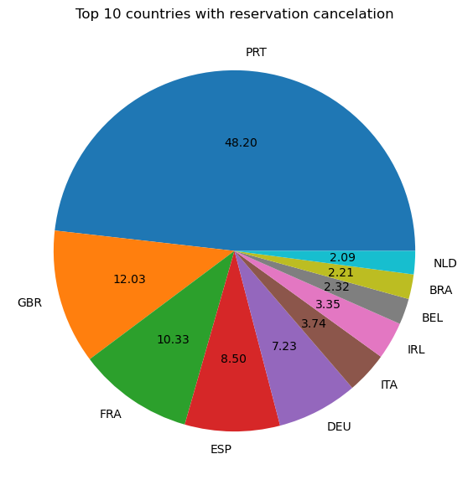

Let’s check the area from where guests are visiting the hotels and making reservations. Is it coming from Direct or Groups , Online or Offline,Travel Agents? Around 46% of the clients come from online travel agencies, where as 27% come from groups. And only 4% of clients book hotels directly by visiting them and making reservations.

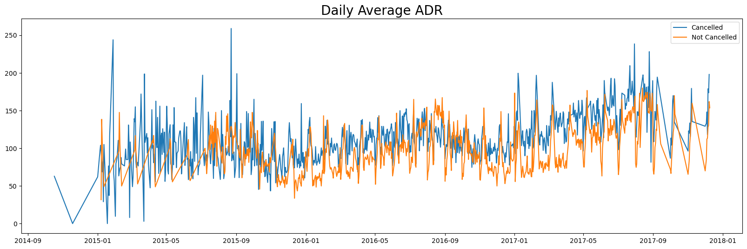

As seen in the graph, reservation are canceled when the average daily rate is higher than when canceled. It clearly proves all the above analysis, that the higher price leads to higher cancellations.